Question – 1 Write a program to calculate the sum of two matrices each of order 3x3.

Ans.

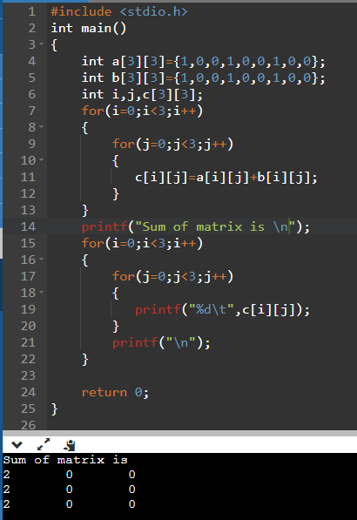

Question – 2 Write a program to calculate the product of two matrices each of order 3x3.

Ans.

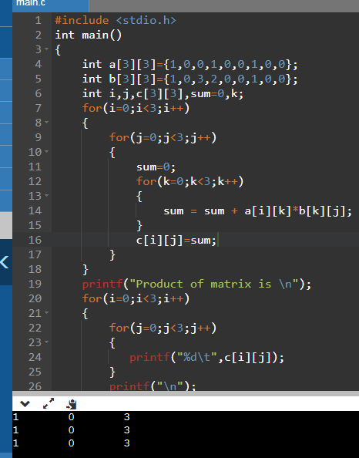

Question – 3 Write a program in C to find the transpose of a given matrix.

Ans.

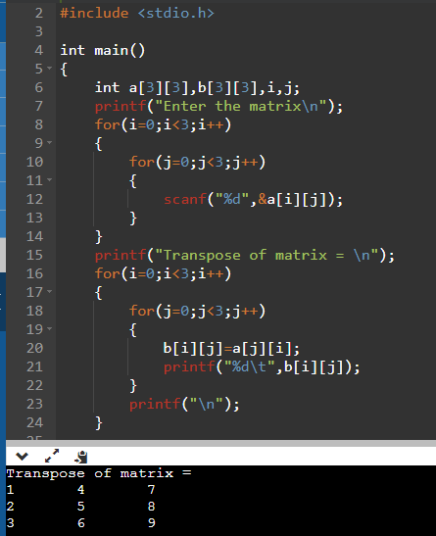

Question – 4 Write a program in C to find the sum of right diagonals of a matrix.

Ans.

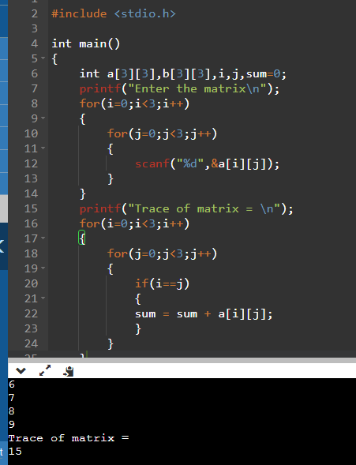

Question – 5 Write a program in C to find the sum of left diagonals of a matrix.

Ans.

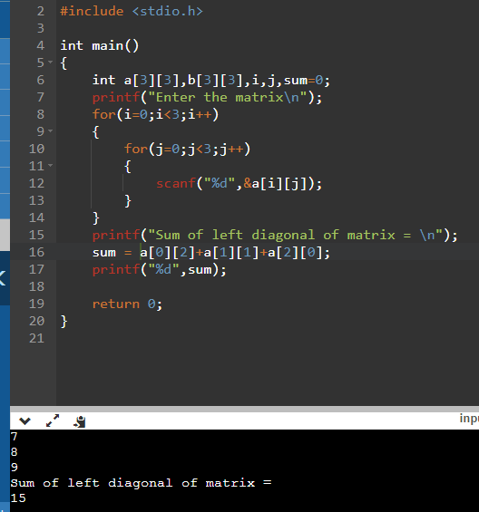

Question – 6 Write a program in C to find the sum of rows and columns of a Matrix..

Ans.

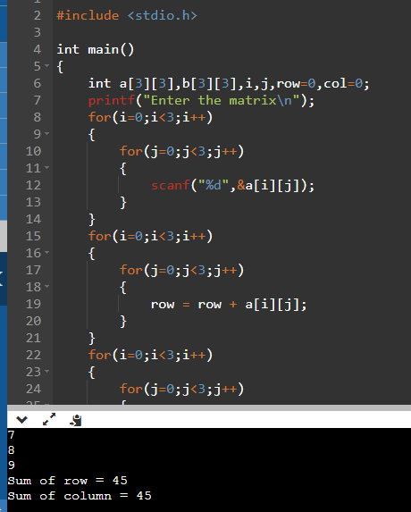

Question – 7 Write a program in C to print or display the lower triangular of a given matrix.

Ans.

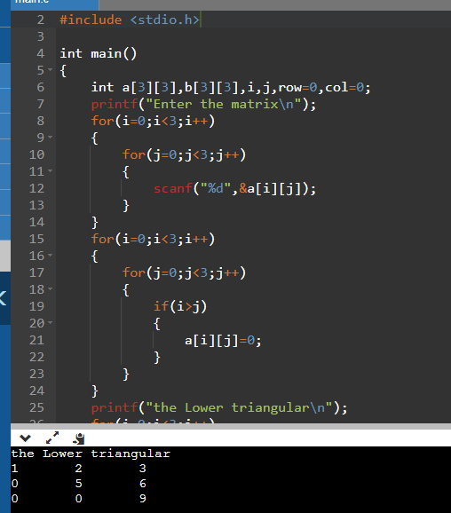

Question – 8 Write a program in C to print or display an upper triangular matrix.

Ans.

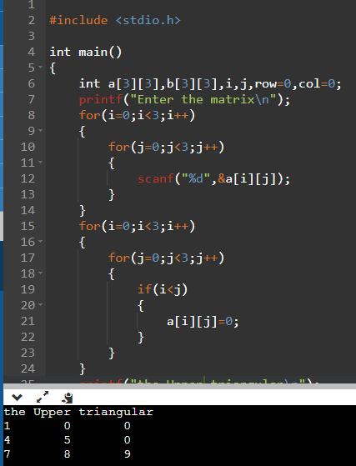

Question – 9 Write a program in C to accept a matrix and determine whether it is a sparse matrix.

Ans.

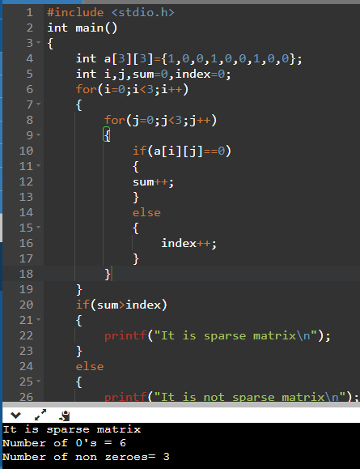

Question – 10 Write a program in C to find the row with maximum number of 1s.

Ans.

